Identity theft: the investigation, implication and prevention on the Jamaican society.

School of Computing and Information Technology
The University of Technology, Jamaica

Ronique Dixon 0603936
Shauntae Mitchell 0903758
Kareem Scott 0900067
Ruth Meredith 0904441

Supervisor: Mr. Ray St. Michael Williams
Acknowledgements

We would like to extend our sincere gratitude to all individuals who made this research a success. To our supervisor Mr. Ray St. Michael Williams from the School of Computing and Information Technology, who helped us in developing our project concept, guided us throughout the academic year and offered support. We also extend our gratitude to Detective Sargent Dodd from the Jamaica Constabulary Force Fraud Squad who took the time out to assist us with our research.
To each member of the group who worked assiduously despite all odds. Also, to Christopher Pearson for continuous support and guidance for the development of our prototype as well as member of the population of Kingston and St. Andrew who took the time out to respond to our questionnaires.
Last, but definitely not least, to God Almighty, for enabling us with knowledge, strength, patience and understanding.
Abstract
In past times, identity theft was not really seen as being prominent in Jamaica, reason being that the public did not hear much about these kinds of incidents. However, in recent times, identity theft crimes have been on the rise in Jamaica. People’s identities (names and other personal information) are being stolen, which can, and has caused serious implications regarding those people. The Jamaica Constabulary Force (JCF) Organized Crime Investigation Division has formed a task force called the “Fraud Squad” to help fight this kind of crime. The Fraud Squad has been successful in locating some of the perpetrators involved in identity theft; however their current strategy only catches these perpetrators after the crime has been committed. As a result, people are still being affected and the implications are still great.
In Jamaica, many transactions require a Tax Registration Number (TRN) to be carried out. As a result, TRNs are being stolen by perpetrators taken other people’s wallet which usually contains a card with the TRN on it and other ways which are putting people in very difficult situations. Perpetrators are using other people’s TRN to conduct their own business without having to pay or use their own money. They are not easily spotted because they use false identification such as fake IDs and fake names. With advancement in Technology, Biometric data can be used to identify a person using their hair, fingerprint etc. as seen in other parts of the world, example: In America, the Department of Homeland Security collects biometric data from applicants for UK visas. This research seeks to find or identify and implement the best way of identifying a person which will result in catching perpetrators before the crime is committed via biometric data or any other means.
The questionnaires and interviews will be conducted to find out which method will be more accepted to implement here in Jamaica. After the questionnaires are answered and the interviews are conducted, the information gathered will help us decide what system to implement for this research. The implementation may be beneficial not only to Jamaica but to the Caribbean on a whole. To build this system, this project will make use of a number of programming languages including C#, JavaScript and HTML.
Table of Content
Chapter 1: Introduction 8
Significance of Study 9
Problem Statement 9
Research Questions 10
Rationale 10
Major Issues and Sub-issues 10
Methods and Procedures 11
Limitation 11
Delimitation 11
Definition of Terms 12
Chapter 2: Review of Literature 13
Introduction 13
Identity Theft 14
Identity Theft in Jamaica 14
Implementation of Anti-Identity Theft in Jamaica 15
Financial Impact of Identity Theft on Jamaica 16
Jamaica Cyber Crime ACT 2010 to help prevent Identity Theft 16
Identity Theft in Other Countries 17
Financial Impact of Identity 20
Identity Theft in the United States 20
Handling Identity Theft in Other Countries 21
Biometric Solution 21
Summary 24
Chapter 3: Methodologies and Procedures………………………………………………………25
Introduction 25
Research Design and Methodology 25
Population Sample 26
Instrument Design 28
Questionnaire 28
Interviews 29
Data Collection Procedure 30
Project Evaluation 32
Data Analysis 32
Procedures 33
Implementation 33
Timeline 35
Chapter 4: Findings……………………………………………………………………………....36
Discussion 56
Chapter 5: Summary, Conclusion and Recommendations 60
Summary 60
Conclusions 61
Recommendations 63
References 65
Appendices 67
Appendix 1 67
Appendix 2 72
Appendix 3 79

Chapter 1: Introduction

According to the U.S. Department of Justice,” Identity theft and identity fraud are terms used to refer to all types of crime in which someone wrongfully obtains and uses another person’s personal data in some way that involves fraud or deception, typically for economic gain” (National Crime Prevention Council, 2005). According to multiple reports in the past year from financial institutions, Government agencies and law enforcement personnel, identity theft is becoming a major problem world-wide and more so a big problem in Jamaica. In recent years we have seen where persons have been using other person’s personally identifiable information to transact business among other things.
In an article written by HELPS (2012), it was stated how identity theft is becoming a prominent issue in Jamaica with the main perpetrators being deportees. Their method of identity theft is falsifying taxpayer registration numbers (TRNs). They would use TRNs to do a variety of things like buying a house in someone else’s name, taking out credit cards in someone else’s name or even paying their own bills using someone else’s identification. As a result of the problems stated, this research will focus on studying the implications that identity theft has on Jamaican society and determining what can be done in order to reduce its occurrence.
It is important to note that the key independent variable within this study is identity theft. The impact identity theft has on society and the preventative measures that can be put in place should be considered as the dependent variables.

Significance of Study
This study aims to identify and combat the growing issue of identity theft in Jamaica. It will prove to be beneficial to society since it will provide a way in which we can minimize the occurrence of identity issues. As a result, consumers will become more confident in conducting business transactions that will require a TRN and law enforcement officers will be more proactive in fighting crime in identity theft.

Problem Statement
According to an article by Tax Administration Jamaica, many business transactions such as obtaining a driver’s license, paying GCT, filing tax returns and obtaining a road license will require a Tax Registration number (TRN). This has consequently led to a new problem in Jamaica called identity theft. The main issues to be addressed are: the falsification of TRNs and the embezzlement of an individual’s identity. Thieves may steal consumers’ identities by “checking though garbage for bills, pretending to be financial institutions and sending requests for personal information, stealing wallets, purses or mail, or by bribing someone with access to this information” (Consumer Affairs Commission, 2011). Identity theft has major implications for the victims involved. In an article by the Consumer Affairs Commission (2011), it was stated that identity theft can deprive consumers of their funds, destroy credit ratings and ruin reputations. The Jamaica Constabulary Force Fraud Squad has been seeing more and more cases of identity theft in Jamaica, especially where deportees are concerned.

Research Questions
- In what way does the government implement plans to combat identity theft in Jamaica?
- What are the significant impacts of identity theft on the Jamaican citizens?
- What are the perceptions of Identity theft by Jamaicans?

Rationale
This study is intended to provide a possible solution that is acceptable to the public to reduce the impact of the falsification of TRNs and the loss of individual identity and combat this increasingly alarming problem known as identity theft.

Major Issues and Sub-issues
In an ever changing world where the use of technology is at the forefront of persons daily activities, we see where there is now an emergent trend where individual's identity are being tampered with. This new trend in Jamaica, caused from deportee all across the globe has created multiple concern of the safety of persons to do business online and physically. The major components to be tackled through this research are identity theft both from physical and online means, fraud to a lesser extent, the reduction in criminal activities such as duplication of devices that house personal data, non-contribution to poverty and unnecessary lawsuits.

Methods and Procedures
The research method that will be used in this study is the qualitative method. This method is being used to assist researchers in gaining a better understanding of the methods perpetrators use to conduct identity theft. The instruments that will be used to support this method are interviews and questionnaires. These instruments were chosen because they are seen as the best tools that can support this goal. Interviews will be conducted at the Tax Registration Office and also the Jamaica Constabulary Force Fraud Squad while questionnaires will be handed to civilians.

Limitation
This research will be conducted in Jamaica but majority of the activity will occur in Kingston to determine the negative impact identity theft can have on the country. Given the fact that identity theft is just on the arisen in Jamaica it is going to be difficult and expensive in gathering and retrieve information for this study

Delimitation
The different kinds of identity theft are typically grouped into four main categories of identification such as Financial Identity Theft, Criminal Identity Theft, Identity Cloning and Business & Commercial Identity Theft. This research will be focus on financial identity theft and identity cloning. Financial Identity Theft is the use of violating the name or Social Security number of another in an effort to reap goods and services while identity cloning is the using of information of another to take over his or her identity on a day-to-day basis. These two were chosen because they are the more prominent ones.

Definition of Terms
TRN (Tax Registration Number) - TRN is a unique nine-digit identification number assigned to each individual taxpayer, business enterprise, organization (non-profit, partnership, charity, etc.) in Jamaica by way of an automated system.
Fraud - deceit, trickery, sharp practice or breach of confidence, perpetrated for profit or to gain some unfair or dishonest advantage.
Identity Theft- an instance in which an individual’s personal information is used by another to facilitate an act of fraud.
Deportee- is a person who has entered into a country either legally or illegally and is ordered by the authorities to leave the country.
SMS (Short Message Service) - is a text messaging service component of phone, web, or mobile communication systems, using standardized communications protocols that allow the exchange of short text messages between fixed line or mobile phone devices.
PKI (Public Key Infrastructure - enables users of a basically unsecure public network such as the Internet to securely and privately exchange data and money through the use of a public and a private cryptographic key pair that is obtained and shared through a trusted authority.

Chapter 2: Review of Literature

Introduction
"Identity theft does not discriminate. It is happening to the rich and the powerful. It is happening to the average person on the street “(Gertler, 2011).
According to the authors in Perspectives on Identity Theft, identity theft can be referred to as an instance in which an individual’s personal information is used by another to facilitate an act of fraud. The term identity theft, which did not appear until the late 1980s, was initially used to distinguish individual victims (identity theft) from collective victims (identity fraud) – both of whom were harmed by the same set of criminal activities (McNally and Newman, 2008). The US Identity Theft and Assumption Deterrence Act (1998) states that identity theft occurs when a person “knowingly transfers or uses, without lawful authority, of a means of identification of another person with the intent to commit, or to aid or abet, any unlawful activity that constitutes a violation of Federal law, or that constitutes a felony under any applicable state or local law”.
The incidence of identity-related crime has increased considerably since the advent of computers and Internet owing to the ability of digital technologies to facilitate the fabrication and alteration of documents used to establish identity, and to enable personal information to be located with ease from electronic databases (Smith, 2008).
This literature review explores the body of knowledge related to identity theft as well as different ways in which it is being done. It attempts to demonstrate the practicality of fully exploiting the use of Biometric Data in attempting to minimize identity theft, highlighting the long-term benefits of implementing this type of system.

Identity Theft
A poll conducted by Ipsos-Reid (2006) found that 4% of Canadians have been subject to identity theft and 20% know someone who has been affected. Studies have shown that criminals may gravitate towards identity theft because the risk of getting caught is not very high. According to CIPPIC (2007), identity theft has become a crime of choice for criminals because of “the possibility of a very high return combined with a very low risk of getting caught. Few individuals are ever charged with and convicted of identity – theft related crimes”. Access to personal information of individuals is readily available from a variety of sources. “Hospitals, governments, cell phone providers, credit card companies and other corporate entities regularly collect and store this information, sometimes without the knowledge and consent of the individuals concerned and not always with appropriate safeguards”. Advancement in technology has also facilitated the ability of thieves to steal personal information. CIPPIC (2007) also noted that the use of copying equipment, computers, and the Internet and data warehouses is used to acquire information.

Identity Theft in Jamaica
Researcher Helps (2012) pointed out that Identity theft is a big deal not because of loss of money but it is because of the implications that it has on an individual. It is taking over someone persona. “Falsifying Taxpayer Registration Numbers (TRNs) is the fastest growing form of identity theft”, (Helps, 2012).There has been an increase in the number of identity theft in Jamaica which is driven by deportees without established identities and just wants to get something and move stated by superintendent Clifford Chambers to the Jamaica observer in 2012.
Researcher Tyrone Reid (2012) reported that The Department of Correctional Services uncovered what appears to be an elaborate identity-theft scheme involving fraudulent taxpayer registration numbers (TRN) and fake voters' identification cards in the name of employees. “Evidence revealed that staff members’ names and identities are being used to access loans without the individuals even knowing. It was observed that the applicants used Electoral Office of Jamaica issued ID cards with the same name of staff members but with a different photograph, the same TRN number but the photocopied TRN card that is on the application form is different from the card being held by the actual employee,” said Lieutenant Colonel Sean Prendergast (Reid 2012).

Implementation of Anti-Identity Theft in Jamaica
In an article published in the Jamaica Observer in October 2012, it stated that the Registrar General’s Department (RGD) has increased its efforts to combat an underground fraud network that the agency says is involved in widespread identity theft. They have created an Authentication, Verification and Identity Department (AVID), which conducts record updating and verifies supporting documents and vital records. RGD stated that perpetrators are stealing identities from both living and dead people. For the financial year of 2011, 150 copies of birth certificates were taken and confiscated from people. Most of these people were visa applicants. RGD's acting marketing and planning manager, Hazel Cunningham, stated that the agency will create a greater public awareness about identity theft by embarking on a number of community outreach programmes and they will also work along with the Passport, Immigration and Citizenship Agency and embassies.

Financial Impact of Identity Theft on Jamaica
In Jamaica, financial institutions are now being given direct access to the TRN database, and credit card fraud should become more difficult when plastic fitted with microchips are introduced locally next year (Thame 2012).Banks in Jamaica lose millions of dollars annually due to cloning of credit and debit cards. Wendell Smith, overseer of information technology at Jamaica National Building Society (JNBS) stated that presentation of TRNs at the bank to carry out transactions is a procedure that is done on a daily basis. When the number is presented, it would be checked to make sure it belongs to the person presenting it. This poses a lot of problems sometimes as people come in with falsified TRNs. The police have identified falsifying taxpayer registration numbers in Jamaica as the fastest-growing form of identity theft.
Smith also stated that a consortium inclusive of MasterCard and Visa is going to make credit cards with chips compulsory in the Latin America and the Caribbean in 2013(Thame 2012). All financial institutions will have to change out the existing cards and replace them with the chip cards. As a result, it will be more difficult for the cards to be cloned which will reduce the illegal use of credit cards.

Jamaica Cyber Crime ACT 2010 to help prevent Identity Theft
- In this Act ----
- “Damage” for the purposes of section 3(3), 5(3), 6(5), 7(2) and 8(2), means any impairment to a computer, or to the integrity or availability of data that---
- Causes economic loss;
- For the purposes of this Act, a person obtain access to any program or data held in a computer if he causes a computer to perform any function that ----
- Copies or moves the program or data to any storage medium other than that in which the program or data is held or to a different location in the storage medium in which the program or data is held.
- For the purpose of this Act, a person who accesses, modifies, or uses, any program or data held in a computer, or causes the computer to perform any function, does so without authorization if ---
- He is not himself entitled to control the access, modification use or function of the kind in question;
- He does not have consent for the access, modification, use or function of the kind in question from any person who is so entitled;
- A person who knowingly obtains, for himself or another person, any unauthorized access to any program or data held in a computer commits an offence

Identity Theft in Other Countries
The phenomena of identity theft have also affected several other islands in the Caribbean. According to the article entitled “Electronic card fraud and identity theft in the Caribbean” there is a debit card and identity theft beginning to spread over several parts of Bridgetown Barbados (Gill, 2012). According to Jeff Gill (2012) accounts of 17 persons have had their moneys illegally withdrawn from several automatic teller machines. This type of identity theft was referred to as skimming where thieves use a device to steal credit card information. “The card is run through what is called a skimmer which harnesses the name of card holder, account number expiration date, verification/CVV code, and even the PIN number”.
In 2004 the Internal Revenue Service has seen signs of a fraudulent scheme targeting non-resident who have income from a United Sates source spreading in the Caribbean. This phenomenon has surfaced in the Caribbean countries such as Barbados, Puerto Rico, Trinidad& Tobago, and the Turks & Caicos Islands. “The scheme uses fictitious IRS correspondence and an altered IRS form in an attempt to trick the foreign individuals into disclosing their personal and financial data. The information fraudulently obtained is then used to steal the taxpayer’s identity and financial assets” (anonymous, 2004).This practice is referred to as phishing.
According to the article entitled “ID Theft Growing Rapidly in 2009” by Richard Adhikari, identity theft is America's fastest-growing crime. The figure for this crime is going at an alarming rate. “ Report from the Identity Theft Resource Center (ITRC), a nonprofit set up to support and educate consumers on identity theft, U.S. businesses and other organizations suffered 83 security breaches so far in 2009 -- potentially exposing the records of at least 1.1 million people.” Richard Adhikari (2009) further went on to report that updated findings illustrated that the pace of data breaches is increasing. “Breaches struck 656 businesses, government agencies and other organizations last year, an increase of 47 percent over 2007.” According to the article “Identity theft growing 10 percent per year, experts warn” identity theft is growing at a rate of 10 per cent a year and one in four adults in the united State will become victims as well one in 20 adults ( Sparacello, 2010).
According to the article entitled “Largest Identity Theft Case In U.S. History: Amar Singh And Wife, NehaPunjani-Singh, Plead Guilty To Massive Fraud”, ,Amar Singh And Wife, NehaPunjani-Singh, pulls of the largest identity theft case in US history (Compton, 2012). “They would receive information about unknown people from various foreign countries, such as Russia and China, as well as via state-wide suppliers — who would use a skimming device to swipe consumer credit card information at retail or food establishments — and illegal identification-gathering websites”. Singh would employ personnel to shop around the U.S with the counterfeit credit card and I.D cards manufactured using the stolen information.
With identity theft still on the rise and increased measures to combat them, there are yet numerous evidences of identity theft cases still emerging. In a book titled Perspectives on Identity Theft the authors spoke about surveys done by the National Crime Victimization Survey which reveals that in the United States of America Nineteen (19%) percent of the survey sample resided in California, nine (9%) percent in Florida and five (5%) percent in New York, which ranked among the top seven states in America being affected. (McNally and Newman 2008) The survey went on further to note that financial ID was the highest method engaged in followed by criminal ID theft and to a lesser extent cloning. Cloning is where a criminal acquires personal identifiers and then impersonates someone else in order to conceal his or her true identity from authorities. (McNally and Newman 2008) In another survey done by Synovate (2003), it also revealed that “Hispanics and African Americans were twice as likely as Asians and Whites to experience the most serious type of fraud, and also that middle-aged persons tend to become the victims of larger dollar amount frauds.”
In a report done by CBS News in February 2009 gives an overview of a prominent case of identity theft. This is the story of a restaurant busboy in America who stole millions of dollars from celebrities through the use of the Internet and Forbes Magazine’s list of the richest people in America. The perpetrator, Abraham Abdallah decided to target well-known figures such as Oprah Winfrey, Martha Stewart and Steven Spielberg. He is a high school dropout, who has now been charged with criminal impersonation, forgery and fraud. The report gave a synopsis of how Abdullah carried out some of his acts; he would use computers at a library, Web-enabled cell phones, virtual voicemail and hired couriers, to obtained social security numbers, credit card numbers and all vital financial records.
His recent schemes lasted for about six months and requested the services of couriers and even prostitutes to deliver expensive items bought with the victims’ credit cards. He was later discovered through suspicions when he sent an email requesting a large sum of money to Merrill Lynch to send cash to an account to that of Thomas Siebel of Siebel Systems. These kinds of acts are nothing new for Abraham Abdullah as he has had similar offenses in the past for bank fraud from an early age of 18; some of shenanigans were even done outside of the US.
One might ask where does this leaves victims or what effect does this have on them? A recent research points out that there are many reasons to believe that fraud victims suffer just as many, if not more negative experiences than victims of common crime. During a savings and loan crisis in the 1980’s, it was reported that the victims of identity theft (mainly retirees) were extremely distraught leading to a few committing suicide while others developed psychological problems.

Financial Impact of Identity

Identity Theft in the United States
The Internal Revenue Service (IRS) may have lost billions to identity theft. According to Josh Lederman (2012), the IRS may have delivered more than $5 billion in refund checks to identity thieves who filed fraudulent tax returns for 2011. They estimate another $21 billion could make its way to ID thieves' pockets over the next five years. The IRS detected about 940,000 fraudulent returns for 2011 claiming $6.5 billion in refunds, there were potentially another 1.5 million undetected cases of thieves seeking refunds after assuming the identity of a dead person, child or someone else who normally wouldn't file a tax return.

Handling Identity Theft in Other Countries
In Honduras, the National Registry of Persons (RNP), which is in charge of providing identification cards, wants to make it more difficult for criminals to commit identity theft in their nation. The RNP expects to introduce an ID card printed on high-quality laminate containing a microchip that will store the owner’s marital status, social security number, driver’s license, taxpayer number and general medical information (Novoa 2012). They want to introduce a new system because it is rather easy for criminals to create forged documents and so by using high-quality laminate with the chip, the material used will be hard to forge.
In the UK, the General Register Office for England & Wales and its Scottish and Northern Irish counterparts sent encrypted files containing details of everyone who has died in the UK each week to vetted organizations, including credit-checking agencies. The move was intended to prevent criminals using the identities of the dead to open bank accounts, commit benefit fraud or aid illegal immigration (Anonymous 2008). The announcement happened simultaneously with the start of National Identity Fraud Prevention week (a government-backed awareness drive to warn of the risks of ID fraud).

Biometric Solution
“Biometry is a statistical analysis of patterns obtained by compiling readings of physiological characteristics or behavioural characteristics for positively identifying a living person.” (SANS Institute, 2002).According to Gemalto, a company that provides electronic identity solutions, biometrics has quickly established itself as the most pertinent technology for identifying individuals in a fast and reliable way through the use of unique biological characteristics (Gemalto, 2012). Many programs now-a-days are relying on biometrics and these programs that are used for the general public are now seeing rapid development. These programs are being predominantly introduced by national authorities, as the overall management of population’s fingerprints call for tightly regulated legal and technical framework (Gemalto, 2012).
An application/program that has been deployed on a wide scale is the electronic passport. It stores two fingerprints along with the passport photo. Another application that exists mainly in European and Middle East countries is the “national identity cards”. In this application, fingerprints are used to confirm the card holder’s identity before he or she is given access to whatever services are needed.
Vivian Chu (2009) conducted a study among individuals of varying backgrounds and ages to help determine their views on biometric technology. The study revealed that “77% of respondents thought that biometric technologies are a useful tool for authentication of identities…Only 7% were opposed to using biometrics. The technology that respondents most widely accepted was fingerprint recognition”. Chu’s study also revealed that enhanced security was thought to be the greatest benefit of biometric technologies.
In a paper entitled Biometric Technology Stomps Identity Theft, the writer highlighted some of the benefits of implementing Biometric Technology Products (BTP). The reasons for using BTPs include the positive authentication and verification of a person, ensuring the confidentiality of information in storage confidentiality of information in storage or in transit. Other reasons are the non-repudiation of acts or transactions, deterrent of identity theft, convenient, safe, non-intrusive, and reduced administration costs compared to passwords. The effectiveness of BTPs is increased if biometric solutions are implemented in combination with Smart Cards and PKI (Public Key Infrastructure) (Zegiorgis,2012). BTPs help to uphold the protection of information in databases including customers and teller identification using fingerprints, iris and facial recognition, ATM access using iris and facial recognition, transactions in transit over the telephone suing voice recognition, computer-aided online transactions using voice, iris, fingerprint and facial recognition and point of sale (POS) transactions using dynamics and fingerprint (Zegiorgis,2012).
According to CIPPIC (2007), there are various methods that can be used to steal personal information. Some of these methods are “relatively simple and low tech (such as: reading obituaries; stealing mail from homes, businesses and mailboxes; breaking into offices or vehicles to steal files; stealing luggage and briefcases; and rummaging through home and businesses’ garbage)”. Other methods that are more sophisticated will include “stealing or hacking into computers; impersonating clients when calling insurers, credit card companies; using the services of online information brokers; and duplicating magnetic strips on the back of cards. These methods can be exercised either in person or virtually through the internet, phone lines or cell phones.”
Sara Berg from the School of Criminal Justice, University of Albany explores the various techniques used in each form of identity theft. For non-technology related offenses, stealing the victims purse of wallet may provide access to a great deal of data; mail theft , where documents such as pre-approved credit card applications are stolen directly from a mailbox; within an organization , dishonest employees with access to sensitive data can obtain Social security number and other records. On the other hand she went on further to discussed how technology(IT) based offenses occur where personal and credit information can be taken from unsecured online shopping sites; using “pretexting, a method for obtaining personal information under false pretenses mission, an offender could pose as a telemarketer or a financial representative to lure victims in disclosing sensitive information.

Summary
It can be concluded that countries around the world are creating numerous solutions to combat the issue of identity theft. Over the years, identity theft has become a prevalent form of criminal activity. This is proven to be true in Jamaica, where there are little to no laws against machines used to steal a person’s identity. The proposed system may prove to be an efficient method of helping to prevent identity theft in Jamaica. It will be useful to not only the government, but also to businesses and financial institutions.
Chapter 3: Methodology and Procedures

Introduction
In completing this research successfully, the researchers, after confirming the direction of our project research and observing extensive literature, decided to conduct further research on the issue. A suitable research method was selected, a substantial sample size and population was decided on and the contents of the research instrument were formulated. An outline of our timeline in completing this research is demonstrated at the end of this chapter. A thorough analysis of the findings received was done; this will be discussed in the following section.

Research Design and Methodology
The main aim of this research is to identify the main issues with identify theft and what system can be developed and implemented in combating this problem.
The research method that will be used to carry out this research is qualitative research; qualitative research is all about exploring issues, understanding phenomena, and answering questions. The instrument we will use to carry out this will be a questionnaire which would be used to capture information such as preferences and views from the public to decide what kind of system can be best implemented. The questionnaire will be done online in the form of a simple application, using both open and closed ended questions, to get a wide cross section of information from persons all around the island and to gather information faster. The tool used in creating the questionnaire also will aid in analyzing the information carefully and effectively. The research team also decided to do an interview, with personnel from the Jamaica Constabulary Force Fraud Squad.
The direction taken to carry out this research was to create an online questionnaire using Google Drive, this allowed us create the questionnaire, publish it online, get the sample’s feedback, collect & store the information where it is then presented in a spreadsheet and graph for easy and effective analysis. The avenue was chosen because it was it was much faster to create and distribute, quite cost effective and we could capture the responses quicker. The data will be collected and presented with the use of descriptive and inferential statistics. Descriptive statistics involves the graphical presentation of the data and the generation of summary statistics. Inferential statistics involves making predictions or estimations based on statistical evidence available. Using graphs and summary statistics will be effective in providing numerical facts. Conducting an interview will aid us in getting higher level information that cannot be answered by the general public. Seeking the assistance from these professionals from the fraud squad will provide insights on how best we can tackle the issue at hand and implement an outcome that is quite beneficial.

Population Sample
The parish of St Andrew and Kingston was chosen for the selected sample area because they were more reports in those areas on identity theft. The parishes of St Andrew and Kingston were administratively merged to form the Kingston and St Andrew Corporation (KSAC), with a single elected council and a mayor.
St Andrew is a residential populated area and the total inhabitants of the parish is an estimated 540, 715 and the populace of Kingston is 937,700 according to GeoNames geographical database. A random sample technique will be deployed and a sample size of Five hundred (500) individuals will be used for the study. The sample size will be broken down in two groups, two hundred and fifty (250) from St Andrew and two hundred and fifty (250) from Kingston, to get a balance within the sample size between the two parishes. The sample sized will consist of equal numbers of female and male with the age group ranging from nineteen to sixty five (19 – 65) .
The stratified sampling method was used for the purpose of selecting the sample for the study. The sample size was divided into different subgroups or strata base on income, geographical location and education.

Instrument Design
In order to measure the variables in our study, questionnaires and interviews will be used to collect the data required.

Questionnaire
The researchers will develop the questionnaire using the problem at hand along with the research questions. In order to gather quantitative and qualitative information, both open ended and close ended questions will be used. The questionnaire will be developed based on the following considerations:
- The information that is needed
- How questions should be framed
- The willingness of respondents to answer the questions
- The wording and order of questions
Questionnaire validity refers to whether or not a questionnaire measures what it intends to measure. Questionnaire reliability refers to the extent to which a questionnaire is repeatable and yields consistent scores. Questionnaires can be seen as reliable once it can reproduce similar results when administered to the same set of people on separate occasions.
A questionnaire is an appropriate instrument for collecting information for a number of reasons:
- They are relatively easy to create and interpret.
- Since the questionnaire will be administered online, the researchers will be able to contact large numbers of people quickly and efficiently.
- They are an effective means of collecting quantitative data.

Interviews
Interviews will be conducted face – to – face and the questions asked will be semi – structured, which will involve the researcher asking a series of open ended questions. The questions will be set beforehand so that the researcher will be able to have an idea of the type of information that will be provided. Issues such as confidentiality, setting of interviews, the length of interviews and methods of recording data will be taken into consideration.
An interview is a subjective instrument. The reliability and validity of an interview will depend on the skill of the interviewer. Validity will also decrease if different persons interview different candidates. Only one researcher will therefore be responsible for interviewing respondents in order to increase validity.
It was decided that interviews should also be used as an instrument because they would be able to provide the researchers with qualitative information that would be useful to the research. Interviews are an appropriate instrument because:
- They allow the researchers to investigate issues in an in – depth way.
- Clarification can be made for ambiguities and the researcher will be able to follow up on incomplete answers.
- They allow for more detailed questions to be asked.

Data Collection Procedure
One of the data collection tools utilized in this research is the questionnaire; they were administered to approximately five hundred (500) persons in the Kingston and St. Andrew area. Each member was responsible to administer at least 100 questionnaires each. The questionnaire were designed in a way that will gain the general public’s perception on identity theft and also ways in which they think identity theft can be solved or minimized. This was done using Google form which is an online questionnaire tool that is found in Google drive. After the content of the questionnaire were finalized it was created online by clicking Google drive, create in the top left corner, then form, this takes you to the framework for successfully creating the online questionnaire. At the end of creating the online questionnaire a link is presented which is then distributed to potential respondents. Emails, social media, and other online platform aided in the distribution of the questionnaires. They were done online so that distribution could be faster, easier and cheaper. Using this tool will allow the researchers to easily get the sample’s feedback, collect and store the information where it will then be presented in a spreadsheet and graph for easy and effective analysis. This approach also aid in quick and easier analysis of the data presented in our findings.
Along with the questionnaire, an interview was held with a detective sergeant who is a member of the Jamaica Fraud Squad. This interview was successful in providing information about the measures that the government has in place to tackle identity theft. The questions that were presented focused on giving the researchers a better understanding and new information regarding what methods are successful or unsuccessful in catching perpetrators of identity theft. The interview questions and responses are included in the appendix along with the letter that was sent requesting permission for the interview.
The researchers will interview personnel from the JCF Fraud Squad at one of their headquarters. The questions that will be presented to the Fraud Squad is focused on giving the researchers a better understanding and new information regarding what methods were successful/unsuccessful in catching perpetrators in the past. The personnel will be briefed about the research and the proposed system for this research. This will then be followed by the question and answer session.
The questions that will be presented to the Fraud Squad personnel are as follows:
- How long has the JCF Fraud Squad been functional?
- What are the dominant ways in which criminals gain an individual’s identity?
- What methods do you use in combating identity theft?
- How effective are these methods?
- What regions in Jamaica are most affected by identity theft?
- What are the most popular form of identification
- On an average, how many cases of identity theft have been reported within the last two years?
- On an average, how many of these reported cases have been solved or the perpetrator has been captured?
- What kind of system would you recommend to best combat identity theft in Jamaica.

Project Evaluation
By using information that was gathered in the findings of the research, the researchers designed a prototype of the proposed system. The following questions will be used as a guide to aid in determining how effective the project was.
- Is the prototype able to send notifications to customers?
- Does it effectively search the databases for an individual?
- Does it send a report/create a red flag when entering already existing personal information (for example, TRN)

Data Analysis
The direction taken to carry out this research was to create an online questionnaire using Google Drive. This allowed us create the questionnaire, publish it online, get the sample’s feedback, collect & store the information where it is then presented in a spread sheet and graph for easy and effective analysis. The avenue was chosen because it was it was much faster to create and distribute and we could capture the responses quicker.
The data will be collected and presented with the use of descriptive and inferential statistics. Descriptive statistics involves the graphical presentation of the data and the generation of summary statistics. Inferential statistics involves making predictions or estimations based on statistical evidence available. Using graphs and summary statistics will be effective in providing numerical facts.

Procedures
The section will give step by step how the project was fully implemented and integrated and the tools used to do so.

Implementation
The technologies used in the implementation of the application are:
- SQL Server 2008
- Visual Studio 2012 and C#

Using C# to communicate between

Timeline
The table below illustrates the project’s timeline, it gives …

Key | Task | Predecessors | Duration (days)
A | Formulate Project objectives | - | 2
B | Review extensive literature |  | 7
C | Develop Questionnaire and interview questions |  | 3
D | Distribute questionnaires |  | 2
E | Review questionnaires |  | 2
F | Develop Database |  | 2
G | Coding and Development of Prototype |  | 30
H

Table 1-
Chapter 4: Findings

Introduction
The main objective of this research was to do an investigation on identity theft in Jamaica, highlight its implications and to provide a solution on its prevention. From our research conducted, some light was shed in regards to person’s perception of the issue and how persons would react to the situation, as well as their preference on how they would want the situation to be handled. From the information gathered it was decided to develop a system to combat identity theft using SMS. The system would serve as an effective means of verifying the identity of persons presenting identity information to various institutions, especially financial.
The questionnaire as the quantitative data collection tool, enable the researchers to gather responses which proved useful in the development of our detection system.
The diagrams below provide a breakdown of the questions used in our analysis and depict the responses given for each.

Question 1
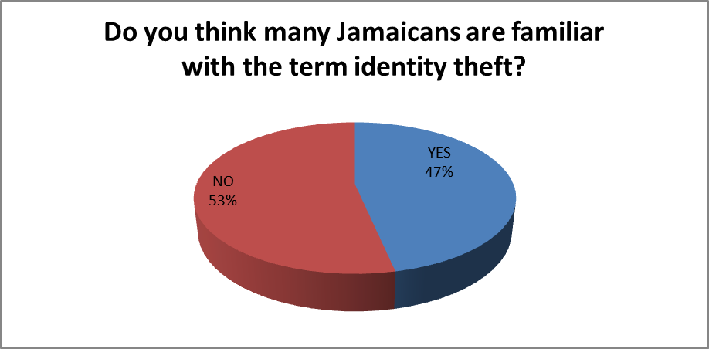
Figure 1
The pie chart illustrates that 47% of the respondents that answered the questionnaires think that Jamaicans are familiar with identity theft while the remaining 53% said that they do not think they were familiar with the term identity theft. For the respondents that stated that Jamaicans were not familiar with identity theft were both males and females with the majority falling in the 19-30 age range.

Question 2

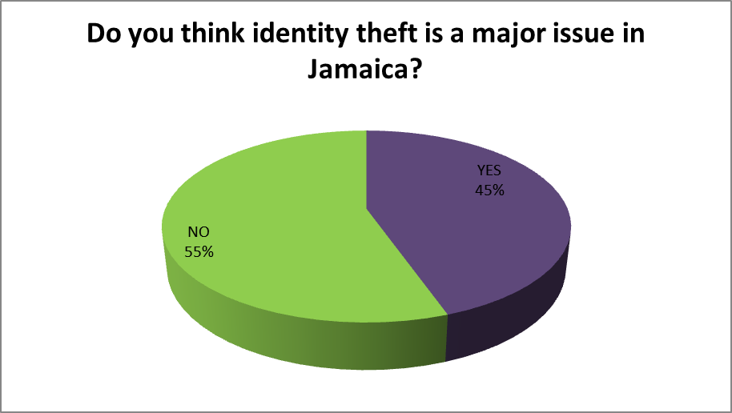

Figure 2
The pie chart shows that 55% of the respondents think that identity theft is a major issue in Jamaica while the other 45% of respondents think that identity theft is not a major issue in Jamaica. Out of the 55% percent that did not perceived identity theft to be a major issue 30% percent were males.

Question 3

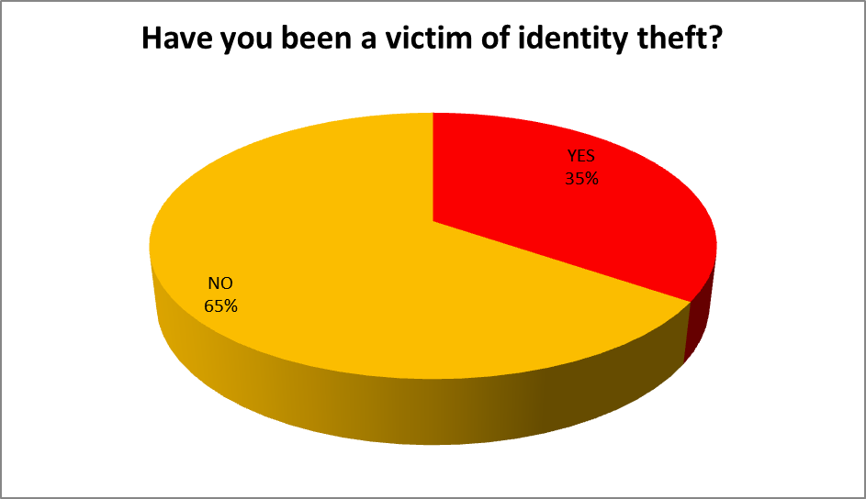
Figure 3
The pie chart displays that 65% of the respondents have never been a victim of identity theft but the other 35% of respondents said that they were victims of identity theft. Our findings indicated that from the persons being affected from identity theft the majority were females in the middle age range which accounted for 40% of the respondents.

Question 4

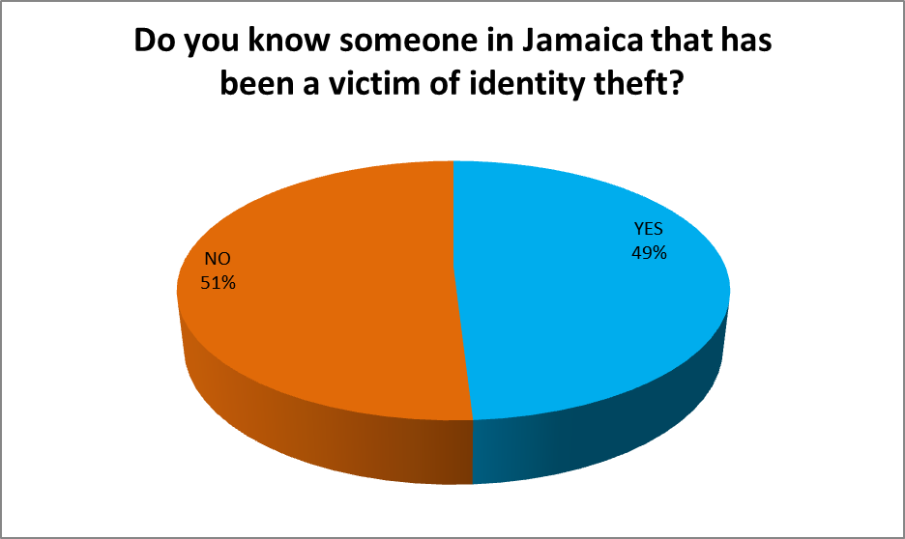
Figure 4
The pie chart shows that 51% of the respondents know someone in Jamaica that have been a victim of identity theft while the other 49% of respondents indicated that they do not know anyone that have been a victim of identity theft.

Question 5

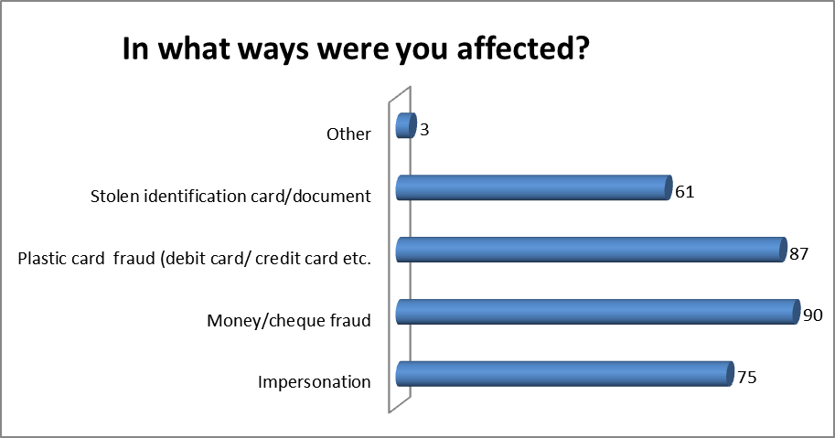

Figure 5
The chart above charts depicts how person were affected from identity theft, seventy-five (75) stated that they were affected by impersonation, ninety (90) said money/cheque fraud, eighty-seven (87) said plastic card fraud, while sixty-one (61) indicated that they were affected through stolen identification card/document. The remaining 3 respondents highlighted that they were affected by the following: Information placed on social networking sites (email, call& biometrics, 19-30, female), Social media and email hacked (2), Stolen land title

Question 6

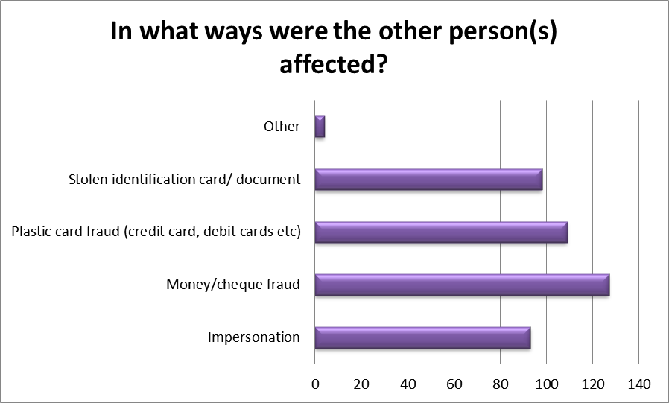

Figure 6
The chart above depicts how persons the respondents knew were affected from identity theft, ninety-three (93) stated that they were affected by impersonation, one hundred twenty-seven (127) said money/cheque fraud, one hundred and nine (109) said plastic card fraud, while ninety-eight (98) indicated that they were affected through stolen identification card/document. The remaining 4 respondents highlighted that they were affected by the following: Forged licenses and documents purporting to be someone else, scamming, social media and hacked email which appeared twice.
Question 7

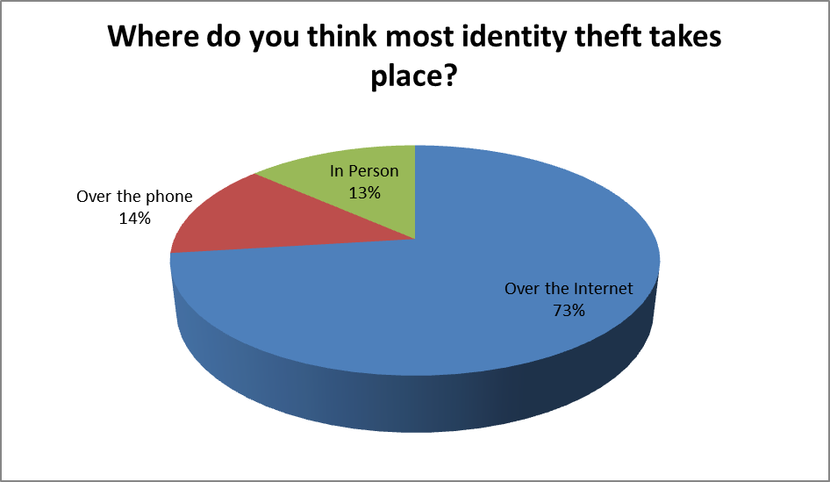
Figure 7
The pie chart demonstrates that 73% of the respondents believe that identity theft is mostly conducted over the internet. 13% indicated that it was in person that people conducted identity theft while the remaining 14% said it was over the phone.

Question 8

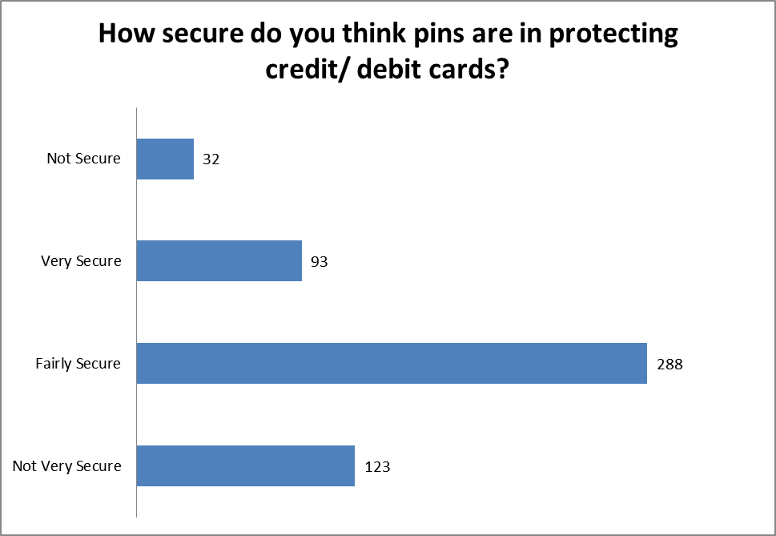
Figure 8
The bar graph points out that majority (288) of the respondents are of the view that pins for debit/ credit card are fairly secure while 32 of the respondents said that they were not sure. 93 of the respondents indicated that the pin was very secure and the other 123 said the pins were not very secure.

Question 9

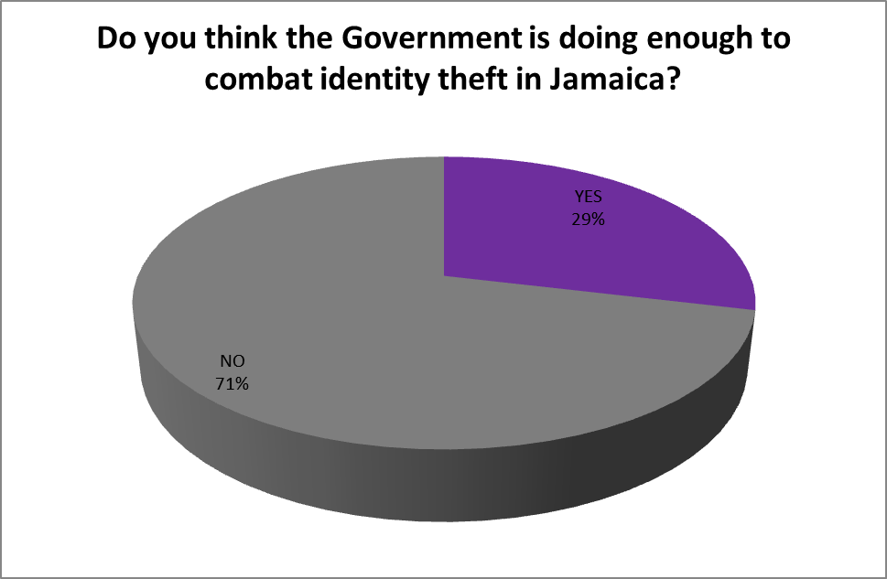

Figure 9
The pie chart shows that 71% of the respondents believe that the government is not doing enough to combat identity theft in Jamaica while only 29% said that the government was doing enough to combat identity theft. The aforementioned was indicated by mostly by males, approximately forty (40%) percent who fell in the younger age group.

Question 10

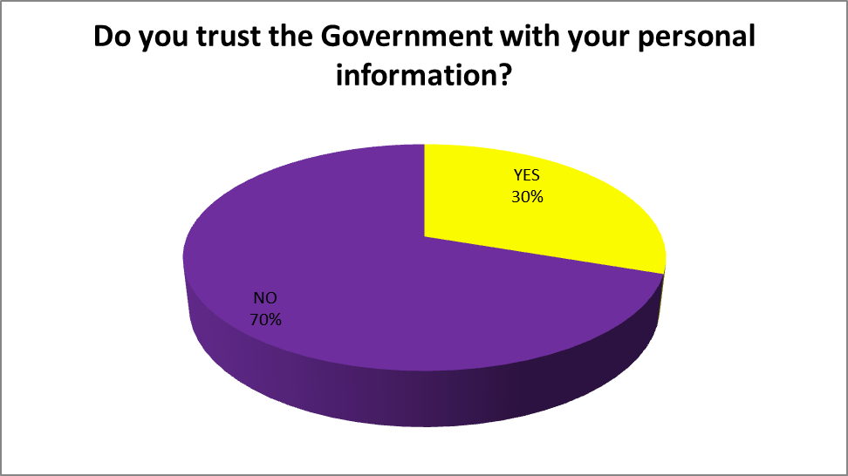
Figure 10
The pie chart demonstrates that 70% of the respondents do not trust the government with their person information but the remaining 30% of the respondents do trust the government with their person information.

Question 11

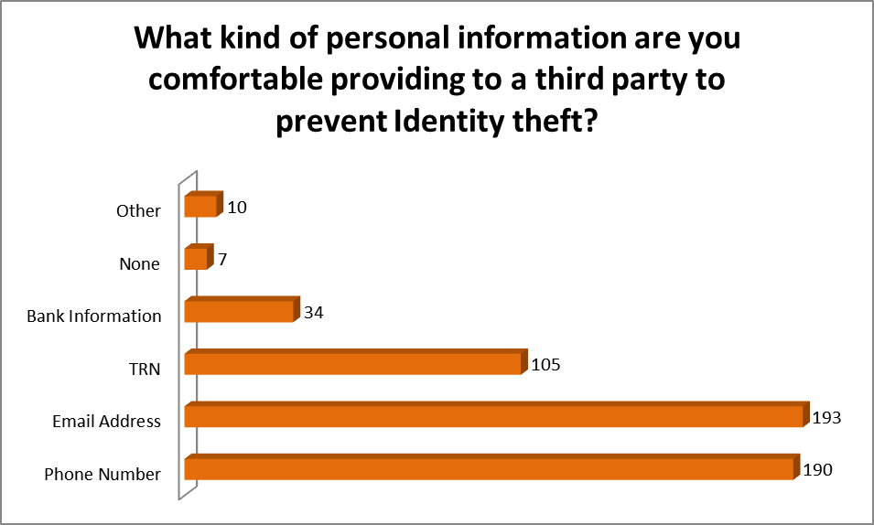
Figure 11
The bar graph shows 190 of the respondents feel more comfortable with providing a phone number to a third party to prevent identity theft, 193 was more comfortable with providing their email address, 105 was comfortable with give their TRN, 34 was comfortable with bank information, 7 said none while 10 indicated other.

Question 12

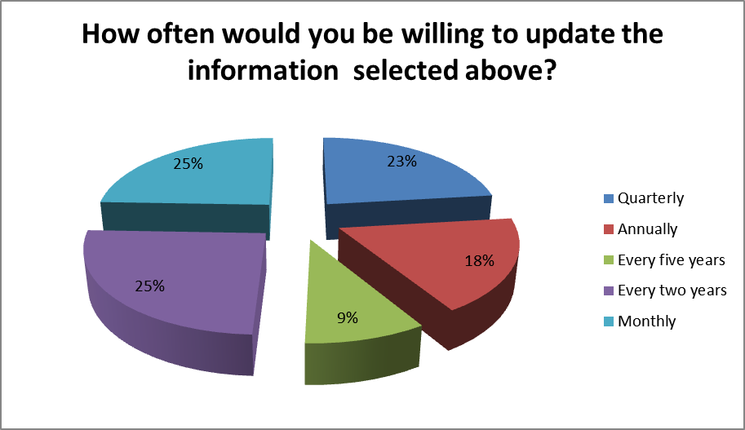
Figure 12
The pie chart demonstrates 25% of respondents indicated that they would update their information every two years and monthly respectively. 23% of the respondents said quarterly, 18% said annually and 9% said every five year.

Question 13

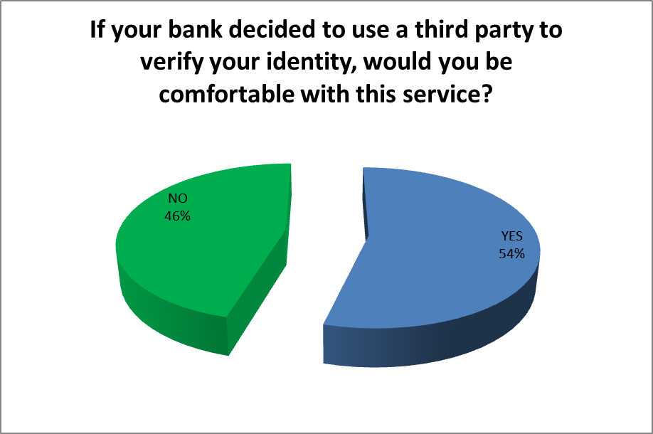
Figure 13
The pie chart shows that 54% of the respondents would be comfortable if a bank use a third party to validate their identity while 46% indicated that they would not be comfortable with the service.

Question 14

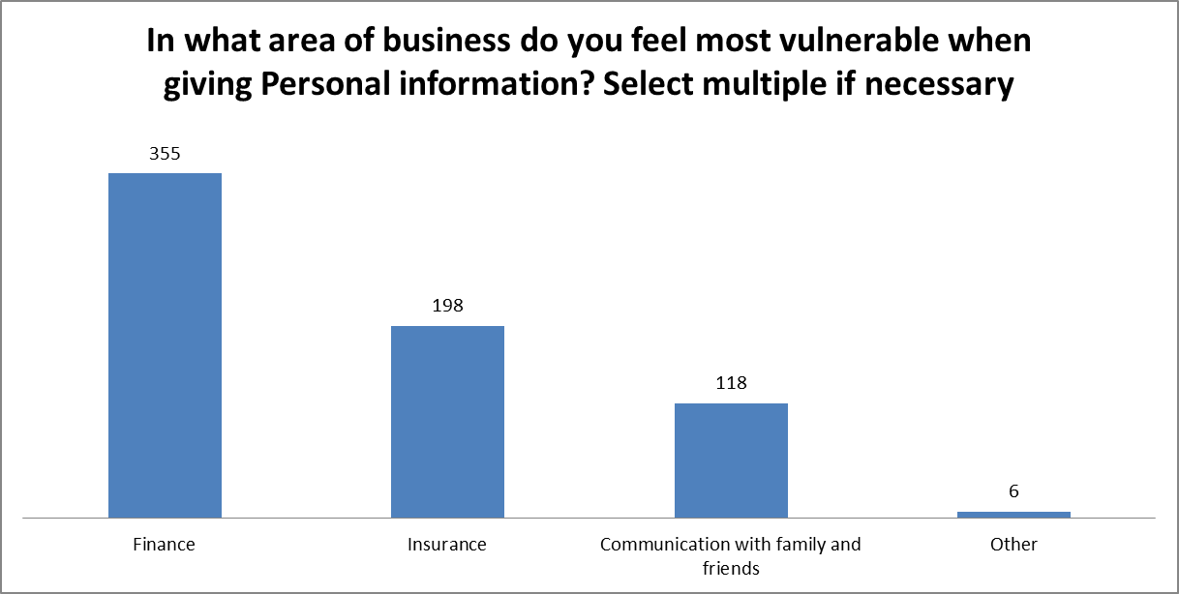

Figure 14
The chart above demonstrates the number of responses given for the area of business persons felt vulnerable. Three hundred fifty-five (355) said finance, one hundred ninety-eight (198) said insurance, one hundred eighteen (118) said through communication with family and friends, while the remaining six highlighted that they felt vulnerable either from purchasing item over the internet, applying for job online, phone tapping at work, western union transaction, conducting business on social media, and general purchases.
Question 15

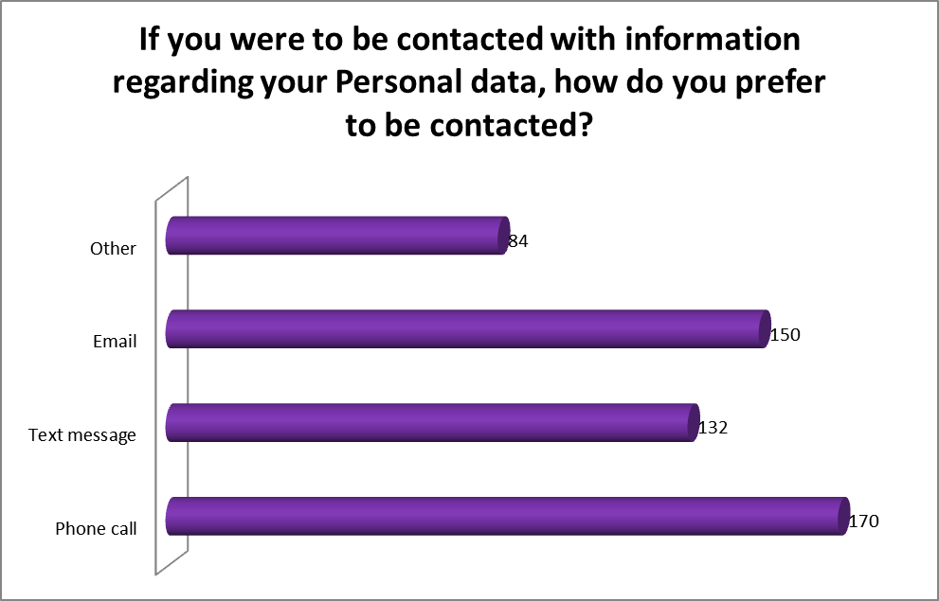
Figure 15
The bar graph illustrates that 170 respondents prefer to be contacted by a phone call regarding their personal data, 132 indicated they prefer text message, 150 said they prefer email and 84 said other.

Question 16

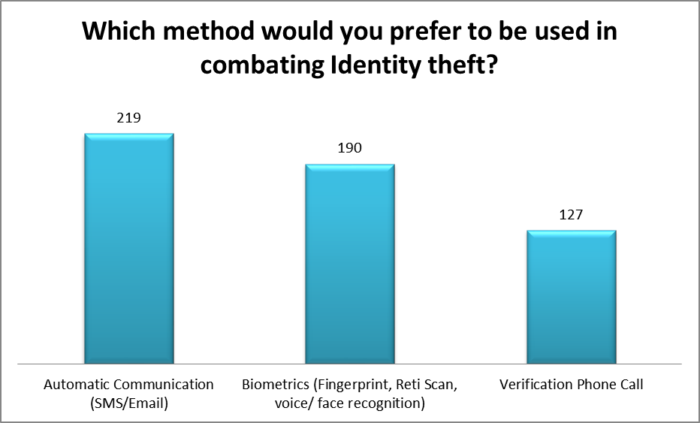
Figure 16
The column chart shows that majority, 219 of the respondents would preferred to combat identity theft using automatic communication (SMS/Email). 190 of the respondents indicated they preferred to use biometrics and 127 said they preferred to use phone call to verify the individual.

Question 17

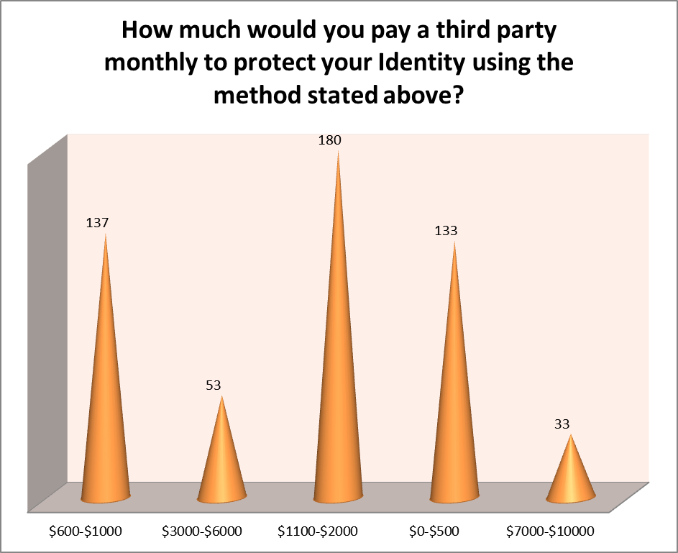
Figure 17
The column chart shows that 180 of the respondents said they would pay $1100-$2000 a month to a third party to protect their identity, 137 of the respondents was will to pay $600-$1000 a month, 133 respondents indicated that they would pay the third party $0-$500, 53 of the respondents said they would pay $3000-$6000 and 33 respondents indicated they would pay $7000-$10000.
Question 18

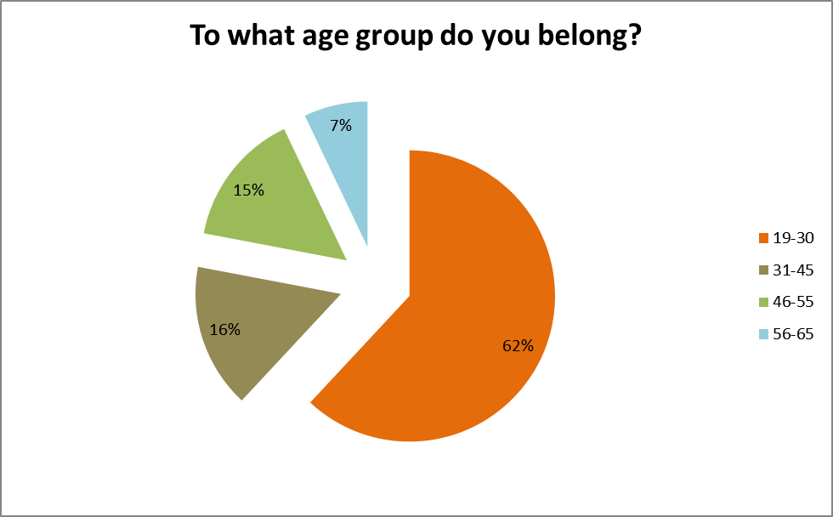
Figure 18
The pie chart shows that majority (62%) of the respondents fall in the age group 19-30, 15% in the range of 46-55, and 16% in the range of 31-45 while the remaining 7% was in the age group 56-65.

Question 19

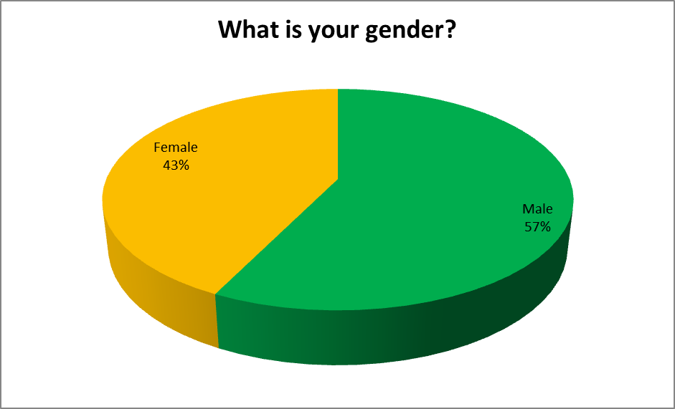
Figure 19
The pie chart shows 57% of the respondents were males while the remaining 43% were female.

Discussion
The purpose of the study conducted was to determine the public’s perception on identity theft. It also sought to find out what methods of alleviating identity theft the public would be more receptive to. In conducting the research, the researchers aimed to answer the following research questions:
1. In what way does the government implement plans to combat identity theft in Jamaica?
2. What are the significant impacts of identity theft on the Jamaican citizens?
3. What are the perceptions of Identity theft by Jamaicans?
Responses provided from the questionnaire indicated that the significant ways in which Jamaicans were affected by identity theft are money/cheque fraud, plastic card fraud, impersonation and stolen identification card/document. This is demonstrated in Figures 5 and 6. A study conducted by Langton and Planty (2010) the unauthorized misuse or attempted misuse of an existing credit card was the most prevalent type of identity theft among 53% of victims.
Identity theft may affect Jamaicans in a number of ways:
- Decrease borrowing privileges- If multiples charges have been made to the victims account it may be hard for the victim to apply for loans, credit cards and mortgages as their credit worthiness will be damaged.
- Financial Loss – One of the most devastating effects of identity theft is that of financial loss. For most identity theft victims, money that is lost is often never replaced. It was mentioned in the literature review that businesses also suffer from major financial implications. Banks in Jamaica lose millions of dollars annually due to cloning of credit and debit cards. It is also interesting to note that most respondents from the questionnaire felt most vulnerable in the area of finance when giving out personal information.
- Shift in economic status- cases of identity theft may lead victims unable to do things they could before in terms of spending, they may also be forced to sell personal assets to cope with loses.
- Psychological trauma- victims can be affected psychologically, feeling a sense of vulnerability when conducting certain business transaction, especially financial. According to an assistant professor in counseling psychology at the University of Alberta, the impact of loss has long lasting effects and no matter how long after they have been victimized the still feel vulnerable.
- Criminal Record – If an identity theft perpetrator gives the victim’s name and personal information when he/she is arrested, the crime will go on the victim’s record.
- False Arrest- due to misuse of one’s identity, there may be cases of false arrest if the criminal commits a crime under a person’s name.
The researchers found that more than half of the respondents (55%) did not think that identity theft was a major issue in Jamaica. It can be assumed that due to the fact that 65% of respondents were not victims of identity theft (as shown in figure 3) could have contributed to that conclusion. It may prove to be problematic if Jamaicans are not aware that identity theft is a growing concern. More effort will have to be placed into informing the public that it is a major issue and that more methods needs to be put in place in order to minimize the occurrence of identity theft.
In relation to the Government majority of respondents (64%) stated that they did not trust the Government with their personal information and the same percentage said that they do not think much is being done by the Government at the moment to combat the issue of identity theft in Jamaica. However, persons felt that they could put some trust into a third party with various kind of personal information to deal with identity theft issues. The areas the persons felt most comfortable with giving a third party is their phone number, email address and TRN which came collectively from ninety (90%) percent of respondents. They also indicated that if the banks wanted to use a third party to verify their identity they would ok with, as stated by fifty-eight (58%). This information solidifies our intention to create a system that would allow communication with persons and their banks using SMS technologies.
In recent years, a case in the US highlighted how the Government had failed to secure person’s personal information. Approximately ninety-four million persons were affected by this data breach. This is an indicator as to how people can easily lose trust in the Government with their information.
Based on the information provided by the respondents, a number of conclusions can be made:
- As shown in figure 7, most respondents (73%) believed that identity theft frequently occurs over the internet.
- Most respondents believe that something else needs to be done in order minimize the occurrence of identity theft. 71% of respondents felt that the government is not doing enough where identity theft is concerned.
- A database system has the potential to minimize the threat of identity theft and consumers will be receptive to this sort of preventative measure. Most respondents (70%) do not trust the government with their personal information and more than 50% of respondents are willing to use a third party to help protect their identities.
- Most respondents would prefer a system that uses automatic communication (SMS/email) to help combat identity theft.
- Most Jamaicans have not familiar with identity theft, especially persons in older age groups; this may be because they have not been victims themselves.
- With the few respondent being affected or know someone being affected by identity theft majority has proven to be females and have been affected in various other ways stated outside of research.
- Person’s perception of the Government being a trusted agent with their information is low, and is mainly the view point of males in the younger age group (19-30).
- Respondents are comfortable with the use of a third party to combat identity theft as stated by fifty-eight (58%) of the respondents of whom approximately 32% were males.
For persons living in Europe, identity theft is not much of a problem expect for in the United Kingdom that had the highest number of incidents in that region. In comparison the U.S. different approaches are taken with how personally identifiable information is used. From a report done da as to how identity theft is being curtailed (Weston 2011).
- Social security number is just for social- it is not used as an all-purpose identifier
- Information is kept private- there are laws that safe guards against selling information
- Most plastic card users are debit cards
- Use of a smart card- credit cards have magnetic strip, in Europe those are being replaced by tiny computer chips which are harder to reproduce

Chapter 5: Summary, Conclusion and Recommendations

Summary
As online transactions increase, the growing request to verify ones identity, and the use of credit and debit cards become more main stream, so does the issue of identity theft. Our research took the avenue of exploring identity theft in Jamaica, who were most affected, persons perception of the issue and what measures can be put in place to combat this issue. Through the topic of Identity theft: the investigation, implication and prevention on the Jamaican society, other methods were observed from other countries to seek the potential benefits of implementing such a system in Jamaica.
Our research questions were to identify:
1. In what way does the government implement plans to combat identity theft in Jamaica?
- What are the significant impacts of identity theft on the Jamaican citizens?
- What are the perceptions of Identity theft by Jamaicans?
Our main objective was to provide a possible solution that is acceptable to the public to reduce the impact of the falsification of TRNs and the loss of an individual’s identity and combat this increasingly alarming problem known as identity theft.
In successfully completing the research the following approaches were taken. The researchers firstly identified the best route to steer the research in through our research questions. Other materials that existed on the topic were used to capture an in depth analysis of the issue plus related topics on the issues. Next we selected an appropriate research method in capturing vital information for our analysis of the problem through the use of questionnaires and interviews.
After our findings were accessed and adequate information was received on the aforementioned issue the researchers went ahead to create a working prototype of a system to alleviate identity theft issue in Jamaica using Asp.Net C# 2010, MS SQL Server 2008 and SMS.

Conclusions
With the use of sophisticated and innovative technologies the development of a system to dampen the horrible effects of identity theft became quite feasible. These technologies include Visual Studio 2012, SQL Server 2008 R2 and OzekiSMS which serve as a great aid in diminishing the reoccurring effects of the aforementioned issue.
Based on the information that was presented in this paper, the researchers were able to make the following conclusions about the project:
- The proposed system will prove to be beneficial to financial institutions in Jamaica, along with the police and the general public as there is currently no measure in place to alarm anyone when an incident of financial identity theft is on the verge of happening.
- The project was effective in determining the public’s perception on identity theft; respondents agreed that identity theft is prevalent in Jamaica but 55% did not see identity theft as a major issue. Determining the public’s perception was achieved through the use of questionnaires and interviews that were conducted. The use of surveys allowed the researchers to garner information that proved to be useful.
- Identity theft is a world – wide problem and there is a need for practical and innovative solutions in Jamaica.
- A system that includes business process procedures is indeed a possible solution for helping to reduce the risk of identity theft. In utilizing proper security methods, individuals may be provided with real – time notifications on the use of their personal information. This system will work along with web applications and web services.
The benefits of implementing this system include:
- An effective means of verifying ones identity
- Prevent loss of money
- Aid in preventing the misuse of an individual’s personally identifiable information
- Provide a customer friendly service to notify persons on the uses of their personal information.
- Can serve as a means in finding perpetrators of identity theft which would be beneficial to the police.
- Reduces the growing impact of identity theft in the island.

The following conclusions can also be made about the findings:
- People believe that identity theft mostly takes place over the internet.
- The significant impacts that identity theft may have on Jamaican citizens include financial loss and a criminal record. Additionally, if a victim has unpaid bills in his name, it may be difficult to apply for loans, credit cards and mortgages.
- Many Jamaicans are not aware that identity theft is a major issue. More effort will need to be placed into educating the public about not only the implications of identity theft but also the measures that can be taken to reduce the risk of becoming a victim.
- Respondents believed that the government may not be doing enough to combat identity theft. Since there are no laws against machines used to steal a person’s identity such as “grabbers”, it may prove to be difficult to dissuade a thief from stealing a victim’s identity. Respondents agreed that more preventative measures need to be put in place in order to address this growing concern.
- Respondents are willing to use a third party that will help to protect their identities by providing them with notifications whenever their personal information is used.

Recommendations
Based on the researchers’ analysis of the findings, it can be said that the conclusions provided are justified in summarizing the key aspects of this research. In order to efficiently implement the suggested database system, the following recommendations should be taken into consideration:
- Even though the prototype presented notifies customers through the use of text messages, the use of email notifications should be added.
- In implementing this system, the issue of security needs to be taken into consideration. Therefore, proper security measures should be in place for the website developed. This may include strong passwords and the use of Secured Socket Layers (SSL).
- Desktop applications should be used for interacting with the government’s databases.
- Further research should be conducted on the effectiveness of the proposed system in combating identity theft. Conducting this research may prove to be beneficial in identifying weaknesses that the system may have.
- Update an individual record in all the database if changes where to occur to individual information
- A schedule can be implemented in the future to update the third party database on a regular interval
- Can be used as an Add on to financial institutions systems
- The incorporation of email to notify individual if their TRN, Passport Number of National ID as be used.

References
Anonymous (2012, October 03). RGD sets up unit to curb identity theft. Jamaica Observer.
Adhikari, R. (2009). Caribbean Identity Theft Scheme.The figures for ID theft are growing at an alarming rate.Retrieved November 3, 2012 from http://www.esecurityplanet.com/news/article.php/3808196/ID-Theft-Growing-Rapidly- in-2009.htm
British Embassy Washington (2011, September 21). Retrieved October 2012, from http://ukinusa.fco.gov.uk/en/visiting-uk/visas/visa-bio
CBS. (2009, February 11). Cybertheft Case Skewers Celebs. Retrieved October 31, 2012, from http://www.cbsnews.com/2100-500164_162-280107.html
Chu, V. (2009).Use of Biometrics, TechCast Article Series. Retrieved from http://www.techcast.org/Upload/PDFs/634122830612738824_Biometrics- VivianandGayathrilo- res.pdf
CIPPIC. (2007, March). Identity Theft: Introduction and Background, CIPPIC Working Paper No.1 (ID Theft Series), Ottawa: Canadian Internet Policy and Public Interest Clinic.
CIPPIC (2007), "Techniques of Identity Theft", CIPPIC Working Paper No.2 (ID Theft Series), March 2007, Ottawa: Canadian Internet Policy and Public Interest Clinic. Crime Prevention Studies, volume 23 (2008), pp.151-167.
Compton, A. (2012). Largest Identity Theft Case In U.S. History: Amar Singh And Wife, Neha Punjani-Singh, Plead Guilty To Massive Fraud.Retrieved November 3, 2012
Consumer Affairs Commission (2011). Identity Theft. Retrieved October 2012, from http://www.consumeraffairsjamaica.gov.jm/index.php?option=com_content&view=articl e&id= 156:identity-theft&catid=66:cac-news&Itemid=29
Dictionary.com. (n.d.).Fraud. Retrieved September 2012, from http://dictionary.reference.com/browse/fraud
Erin, R. (2009, September 5). Catch Him If You Can. Retrieved October 30, 2012, from http://listverse.com/2009/09/05/10-bizarre-cases-of-identity-theft/
Gemalto (2012).Biometrics for use in identification.Retrieved November 5, 2012 from https://www.gemalto.com/biometrics/index.html
Gill, J. (2012).Electronic card fraud and identity theft in the Caribbean.Retrieved November 3,
Helps, H. (2012, May 21). Editor-at-Large. Identity Theft Growing, p. 1. Jamaica Observer.
Ipsos-Reid (2006, March 7). One-Quarter of Canadian Adults (24%) Have Been Touched by Identity Theft. Retrieved October 2012 from http://www.ipsos-na.com/news- polls/pressrelease.aspx?id=2998
Jederman, J (2012, August 02). IRS May Have Lost Billions To Identity Theft. HuffingtonPost
Newman, R., M. M. (2008). Perspectives on Identity Theft.
Novoa, R (2012, June 08) Honduras: Identity Theft Concerns Authority. Retrieved from http://infosurhoy.com/cocoon/saii/xhtml/en_GB/features/saii/features/main/2012/08/06/f eature-01
Quatloos.(2004). ID Theft Growing Rapidly in 2009.RS REISSUES CONSUMER WARNING ON IDENTITY THEFT SCHEME; SCHEME NOW TARGETING CARIBBEAN.Retrieved November 3, 2012 from http://www.quatloos.com/caribbean_ID_theft.htm
Reid, T. (2012, July).Identity theft Hits Prison Service.The Jamaica Gleaner.Retrieved November 3, 2012 from htt://www. jamaica-gleaner.com.
Rouse, M. (2006, October). PKI (Public Key Infrastructure). Retrieved May 7, 2013 from http://searchsecurity.techtarget.com/definition/PKI
SANS Institute (2002).Biometric Technology Stomps Identity Theft. Retrieved October 2012 from http://www.sans.org/reading_room/whitepapers/authentication/biometric- technology-stomps-identity-theft_126
Tax Administration Jamaica (n.d.).TRN Made Easy Individuals. Retrieved October 2012, from http://www.jamaicatax.gov.jm/publications/tax_kit/trn_made_easy_individuals.pdf
Thame, C. (2012, September 8). Clampdown on identity theft.Jamaica Observer.
The Telegraph (2008, October 5). Registrars' death lists 'will fight ID fraud' and identity theft Retrieved from http://www.telegraph.co.uk/news/uknews/law-and- order/3142021/Registrars-death-lists-will-fight-ID-fraud-and-identity-theft.html
United States. House of Representatives (1998, October 30). US Identity Theft and Assumption Deterrence Act. Washington DC.

Appendices

Appendix 1
Questionnaire-Identity theft Survey
We are conducting research into identity theft in Jamaica and the measures that can be put in place to alleviate this problem. This survey is aimed at measuring public perception on Identity Theft. Answers to this questionnaire should be limited to Jamaica. Your participation in this questionnaire will be greatly appreciated and all information provided will remain anonymous and treated as confidential.

Do you think many Jamaicans are familiar with the term identity theft? *
 Yes
No
Do you think identity theft is a major issue in Jamaica? *
Yes
No
Have you been a victim of identity theft? *
Yes
No
Do you know someone in Jamaica that has been a victim of identity theft? *
Yes
No
In what way were you affected? Select multiple responses if necessary.
 Impersonation
Money/cheque fraud
Plastic card fraud (credit card, debit cards etc.)
Stolen identification card/document
Other: 
In what ways were the other person(s) affected? Select multiple responses if necessary.
Impersonation
Money/cheque fraud
Plastic card fraud (credit card, debit cards etc)
Stolen identification card/ document
Other:
Where do you think most identity theft takes place? *
In Person
Over the Internet
Over the phone
How secure do you think pins are in protecting credit/ debit cards? *
Very Secure
Fairly Secure
Not Very Secure
Not Secure
Do you think the Government is doing enough to combat identity theft in Jamaica? *
Yes
No
Do you trust the Government with your personal information? *
Yes
No
What kind of personal information are you comfortable providing to a third party to prevent Identity theft? *
Phone Number
Email Address
TRN
Bank Information
Other:
How often would you be willing to update the information selected above? *
Monthly
Quarterly
Bi-annually
Annually
Every two years
Every five years

If your bank decided to use a third party to verify your identity, would you be comfortable with this service? *
Yes
No
In what area of business do you feel most vulnerable when giving personal information? Select multiple if necessary *
Finance
Insurance
Communication with family and friends
Other:
If you were to be contacted with information regarding your personal data, how do you prefer to be contacted? *
Email
Text message
Phone Call
Other:
Which method would you prefer to be used in combating Identity theft? *
Automatic Communication (SMS/Email)
Verification Phone Call
Biometrics (Fingerprint, Retina Scan, voice/ face recognition)

How much would you pay a third party monthly to protect your Identity using the method stated above? *
$0-$500
$600-$1000
$1100-$2000
$3000-$6000
$7000-$10000
To what age group do you belong? *
19-30
31-45
46-55
56-65
What is your gender? *
Male
Female

Appendix 2
Capstone Research – Identity Theft

Meeting Minutes #1

September 24, 2012

Present: | Ray Williams (Supervisor), Ruth Meredith, Shauntae Mitchell, Ronique Dixon, Kareem Scott
Location:  Time Started:  Time Ended:  Document Prepared by: | SCIT Office  4:00 P.M.  4:30 P.M.  Shauntae Mitchell

Discussion
- A system that uses biometric data would not be the best solution for the project since there will possibly be a large amount of problems associated with it.
- The ‘smart card’ that is used in Europe was suggested as a solution.
- A survey should be done in order to find out what kind of system Jamaicans would be more comfortable with. The Technology Acceptance Model would also be useful with this evaluation.
- The results from the survey will help to determine the type of system that would be more suitable to the project at hand.
- The questionnaire/survey should be distributed before/during December.
- Each member of the group should be responsible for looking at different regions of the world and research how that region deals with identity theft.
Meeting Minutes #2

October 12, 2012
Present: | Ray Williams (Supervisor), Ruth Meredith, Shauntae Mitchell, Ronique Dixon, Kareem Scott
Location:  Time Started:  Time Ended:  Document Prepared by: | SCIT Office  3:00 P.M.  3:20 P.M.  Shauntae Mitchell

Discussion
- Corrections for chapter one of the research project were reviewed.
- More definitions need to be added.
- Sources should be properly referenced.

Comments
A document with all corrections was emailed to each member.
Meeting Minutes #3

February 11, 2013

Present: | Ray Williams (Supervisor), Ruth Meredith, Shauntae Mitchell, Ronique Dixon, Kareem Scott
Location:  Time:  Document Prepared by: | Online  7:54 A.M.  Shauntae Mitchell

Discussion
The literature review was discussed and the following issues were brought up in the discussion:
- More paper references need to be used.
The literature review lacked the following:
- Papers pointing to what is Identity Theft.
- The impact in terms of Monetary or costs associated with various countries and companies
- Countries that have implemented systems to handle Identity theft (Apart from Biometrics)
- Literature or references to Jamaica implementations of Anti-Identity theft.
- Various Forms and Techniques of Identity theft and which is more prevalent Eg. (Online or in person) or Social Engineering Hacks?
- Laws that address Identity theft in Jamaica or laws around cyber-crime.

The solution should be doing the following things:
- Consolidating all identities form the government in a single view. - Passport, Driver's License, National ID, voter's ID
- Allowing secure access to financial institutions. For example VPN, encryption etc. It was suggested that members look up how to transmit data securely.
- Use client notification to combat the theft. It should communicate with customers when their Identity is used and measures should be put in place that will allow them to immediately thwart unauthorized activity. Customers should be able to reply via email or text message. For example, NCB looks up your identity and accesses your record – a SMS or email should be sent. The customer receives the SMS or email and replies if it is not them. That should be flagged in the database.

Comments
The deadline to hand in corrections is February 11, 2013 at 11:59 P.M.

Meeting Minutes #4

February 26, 2013

Present: | Ray Williams (Supervisor), Ruth Meredith, Shauntae Mitchell, Ronique Dixon, Kareem Scott
Location:  Time Started:  Time Ended:  Document Prepared by: | SCIT Office  2:00 P.M.  2:35 P.M.  Shauntae Mitchell

Discussion
- Questionnaire was reviewed.
- More questions need to be included to determine the public’s perception of identity theft.
- The following questions should be addressed in the questionnaire:
  - Do you think identity theft is a major issue in Jamaica?
  - What personal information are respondents comfortable with providing to third parties?
  - What do respondents feel more vulnerable in (example: Finance, Insurance, etc.)
  - Do respondents trust the government with their personal information?
  - Through what ways do respondents think identity theft can be tackled? (Example: SMS, biometrics, Email).

Comments
A document with all corrections was emailed to each member.

Meeting Minutes # 5

April 25, 2013

Present: | Ray Williams (Supervisor), Ruth Meredith, Shauntae Mitchell, Ronique Dixon, Kareem Smith
Location:  Time Started:  Time Ended:  Document Prepared by: | SCIT Office  1:00 P.M.  1:40 P.M.  Shauntae Mitchell

Discussion
- A letter should be written requesting an interview with a member of the fraud squad.
- A website should be created in order to allow new customers to sign up.
- Desktop applications can be used to interact with the government’s databases.
- For the conclusion in the research paper, each point made should state how it will be achieved or how we have achieved it.
- Corrections for chapters four and five should be completed by Shauntae and Ruth.

Comments
The mock interview will be scheduled during the week of May 6, 2013.

Appendix 3
Interview permission letter for the Jamaica Constabulary Force
Superintendent / Supervisor
The Fraud Squad
Jamaica Constabulary Force (JCF)
34 Duke Street

Dear Sir/Madam,
A set of students from the School of Computing and Information Technology from the University of Technology, Jamaica are in the process of conducting a survey in order to gain information on how Government combat identity theft. The group is currently engaged in their major project where they have been charged to research and solve issues of national importance. The students have identified the issue of identity of theft as a pertinent topic and seek to enhance the solutions to Identity theft already employed by the JCF. Their proposed solution involves a two way communication via a technological solution.
This survey is being conducted in partial fulfillment of major project obligation. The interview is a fact-finding interview to better understand what are the current policies, procedures and frameworks already in place to deal with Identity Theft. Please extend the necessary courtesies to the students in their request for an interview.

Yours Sincerely,

________________________________________
Ray St. Michael Williams
Lecturer
School of Computing
University of Technology, Jamaica
237 Old Hope Rd.

